SAAS Delivery Model Modernization

The American Recovery and Reinvestment Act (ARRA) was enacted into law in 2009. It established incentive payments for eligible professionals (EPs), eligible hospitals, and critical access hospitals (CAHs) to promote the adoption and meaningful use of Certified Electronic Health Record Technology (CEHRT)

PowerWorks
The PowerWorks delivery model was first implemented in 2005 leveraging the Millennium platform and applications originally built for the Acute market. The PowerWorks model is a subscription model priced on per provider fee. The intention of this model was to deliver standard workflows for rapid implementation and reduce variability. The challenge became the content needed for the vast array of 50+ ambulatory specialties, i.e., Family Practice, Urology, Podiatry, Oncology, Ophthalmology.

The platform and architecture did not scale down to independent Ambulatory market to allow customers to be in their own domain. The decision was made to create a multi-tenant domain with a logical domain flag to separate independent organizations from having access to information from other organizations. The investment only focused on activity data and some level of the reference data. There was minimal investment for configuration tools to allow customers to maintain configurations at the local level.

The PowerWorks Delivery model currently supports approximately 1,100 Customers with an Annual Revenue of $50M. The pricing model is a subscription $595 Per Provider Per Month (60 Month Term) for customers implementing Specialty Practice Management and $675 Per Provider Per Month for customers implementing Millennium Practice Management. Implementation durations range from 2 to 5 months pending on volume of providers.

Overall Ambulatory Market Penetration is 12% US based health system clinics, 4% US based all clinics – health system and independent. 83% of Oracle Acute clients also have purchased Ambulatory, however only 44% of these clients have Ambulatory deployed system-wide. The sales organization has recently been approved for 15 positions to ramp up the sales of the Ambulatory market for health system and independent clinics.

Competitors and Market Share

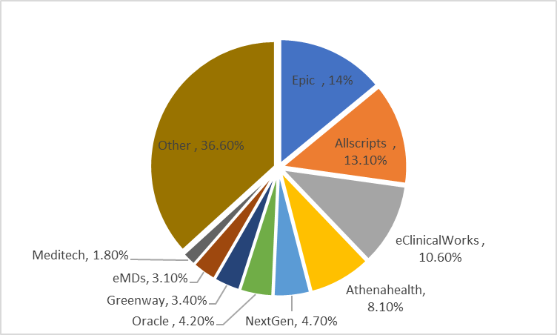

CommunityWorks
The CommunityWorks delivery model first originated in the PowerWorks model in 2008 but with the advent of the incentives the decision was made to create a separate organization to focus on each of the markets. The CommunityWorks business model is like the traditional license software, services, and support model. This model evolved from critical access hospitals to 100+ bed community hospitals. The selling point was the customer could have more specific workflow configuration which has led to variability across logical and physical domains.

The CommunityWorks Delivery Model supports approximately 300 customers in production with 34 customers in implementation or backlog. The annual revenue is $350M.

The pricing for each customer depends on the scope and size of each customer but on average aligns with the following:
Foundations $3-4M
Critical Access $5M-$10M
Community $10M-$20M

The implementation duration and effort are a function of the scope and size of each customer.

Duration Effort
Foundations 6 months 11K Hours
Critical Access 9 months 30K Hours
Community 12-15 Months 50K Hours

Competitor and Market Penetration

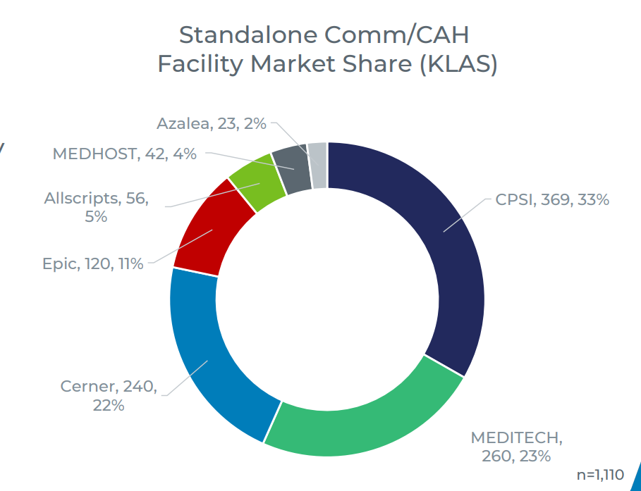

Continuum

The Continuum is comprised of Behavioral Health, Long Term Care, and Inpatient/Outpatient Rehabilitation customers. This multi-tenant model first started in 2013 with five customers within CommunityWorks and then became a standalone business in 2016.

There 51 customers live, generating ~$14M in Annual Recurring Revenue including:
- 39 Behavioral Health
- 8 Long Term Care
- 4 Inpatient Rehabilitation

There are 7 customers in flight, generating ~850K in Annual Recurring Revenue
- 6 Behavioral Health
- 1 Inpatient Rehabilitation

The average implementation is 9-10 month from kick off to go live. For a standard Community Behavioral Health project, the effort sold is 2250 hours. For an Inpatient Behavioral Health or Rehabilitation project (standard package which includes Pharmacy and Millenium Patient Accounting) there are 3700 hours sold.

Key Competitors:

Behavioral Health Long Term Care Rehabilitation
NetSmart PointClickCare Epic
Streamline Healthcare MatrixCare WellSky
Qualifacts CPSI

SAAS Model

The SAAS Model is predicated on expediate customer activation with a low cost to sell, deliver, operate, maintain, and support. The model also includes a level of surveillance to monitor the health of the customer and the environment.
There are many areas the current multi-tenant models are lacking from being considered a true SAAS model. The following will describe several of those areas where near term benefits may be realized by the customer and Oracle Health with investment and focus.
The focus areas below are initially for the PowerWorks model as there is planning underway to significantly grow the market share for the small and large independent practice segments in CY’2024. These focus areas will also have a positive impact on the CommunityWorks model and the traditional standalone Acute market.
This document does not address areas for improvement in sales and marketing in SAAS model.

Cost
There is not a pure line of sight to the actual cost to sell, implement, operate and support compared to the revenue generated. This holistic financial view would give measurement and justification for investments for areas described below.
Action: Drive to bring together and understand the operating and capital costs to identify where to continue to focus to remove or improve on the costs.
Product
- Browser Based Access - A SAAS product is accessed over the internet on any device with the need to download information. The work being done with the New Millennium efforts is expected to address the workflow. The transition to a browser-based application will have an impact on operational and capital costs.

Action: Engage with the Clinical/Revenue Cycle Product groups on the roadmaps to move to browser-based applications and under the impact from a usability and costs to operate.

- Upgrades – The upgrade process is manual and labor intensive with testing and issue resolution.

Action: Baseline and analyze the time and effort and to perform major upgrades i.e. 2018.19 and monthly maintenance updates to determine where improvements need to be made to accelerate the process and quality of upgrading the product set.

Action: Continue engagement with the Release Management organization to contribute to the testing and quality of application prior to general availability.

Action: Accelerate the automation of manual regression test scripts. There are currently 15.5% of regression test scripts are automated.

- Release of Innovations – The process to release many new innovations and content is labor intensive and often a manual process.

Action: Identify and document areas of improvement to remove and/or auto the manual steps to release innovations to the domain(s).

- Reporting and Analytics – customers have limited ability to create operational reporting and compliance reporting necessary to run their business. This is currently developed internally on per customer service request.

Action: Continued engagement with Oracle Analytics on roadmap for Analytics platform.

Delivery
- Customer Onboarding – the current process for setting up a customer in a logical domain is a manual process.

Action: Engage with the customer delivery team to understand the steps necessary to set up a logical domain for an individual customer to automate the manual steps.

- Configuration Tools – the local configurations necessary to implement a customer are documented but a manual process and across many individual build tools. These tools are not browser based and are dependent on Citrix to deploy. Many of these tools do not honor the logical domain security allowing customers to self-serve for implementation configuration and maintenance.

Action: Develop a product that is browser based, honors the logical domain security, and guided configuration process to allow the delivery teams, customers, and application managed services teams to implement new customers and support existing customers efficiently and effectively.

- Self Service Integration – currently customers depend on Oracle Health employees to implement and configure repeatable integration points i.e. lab results, hie connections, clinical registries.

Action: Develop the tooling that allows customers to set the necessary configurations to create the connections and trigger the appropriate information to the receiving entities.

- Data Migration Strategy – Prospective customers are more than likely using an Electronic Medical Record. Most prospective customers went from paper or scanned records to the Electronic Medical record. Customers will want to migrate a level of activity data as well as leverage local reference data in a new EMR. This will become a barrier for new customers wanting to change to a new EMR.

Action: Understand what strategies are leveraging leveraged today by the consulting and deliver organization to determine the state of data migrations for customers transitions from an EMR and identify the gaps to remove this barrier for prospective customers.

Support
- Self Service Management – there are over 40,000 service requests each month from customers for local and global build configuration that customers are unable to perform due to the complexity of the tools and the tools do not honor the logical domain security.

Action: Similar to #2 in the Delivery section, develop a product that allows customers and employees to effectively and efficiently to make configuration changes. (see appendix)

- Critical Incident Notification – the primary customer communication channel is leveraging the Ucern platform. This is not an effective means of communication to notify customers of critical issues.

Action: Research alternative and more effective means for notifying key customer contacts when there is a critical issue.

- Surveillance: There are many forms of surveillance of varying degrees. There is a higher degree of monitoring that would benefit our customers and Oracle regarding technology, adoption, utilization, support, and customer success metrics.

Action: Evaluate the current state of the various surveillance tools and what is being monitored. Then document a future vision of an inclusive surveillance strategy that would benefit both the customers and Oracle Health.

